**09/03/2014**

**Web Applications**

**Assingment 1 : Horse Sale Web Form**

**Martin Zuber**

**B00066378**

**Group 3**

Empty Form

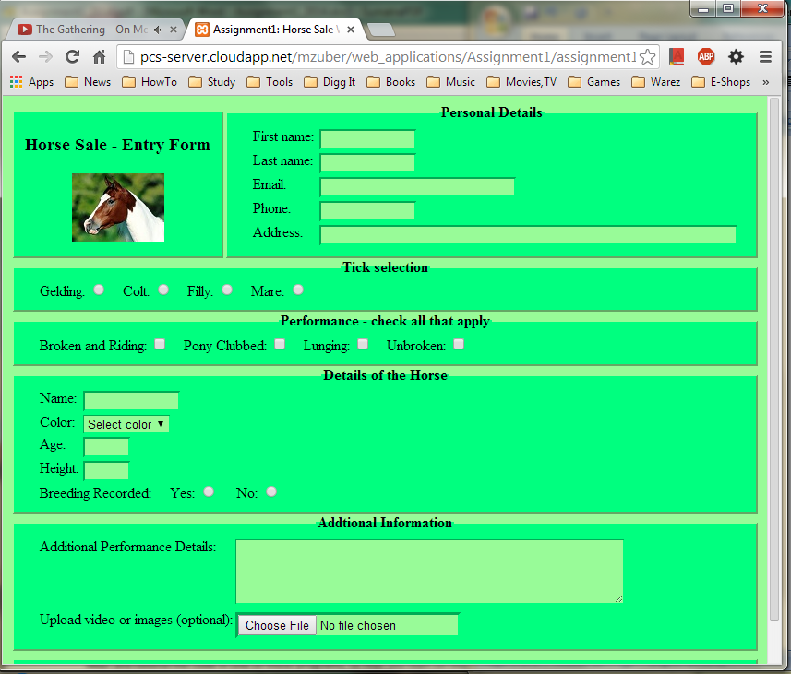

Figure 1

Error Messages

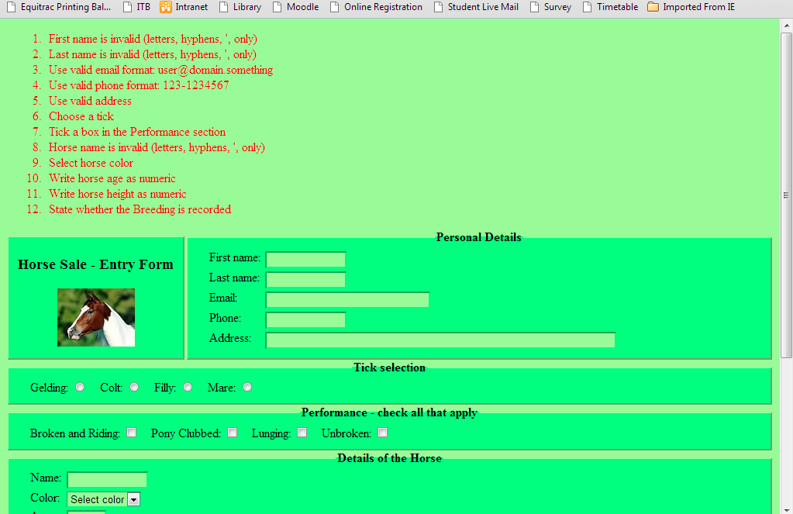

Figure 2

Filled Up Form

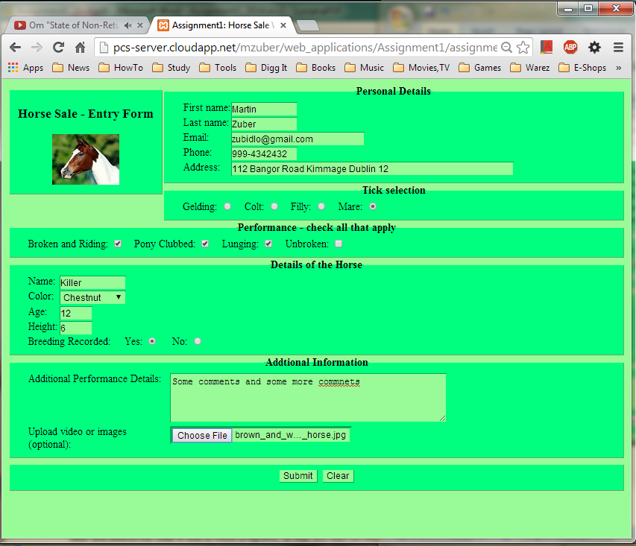

Figure 3

Entries Submitted

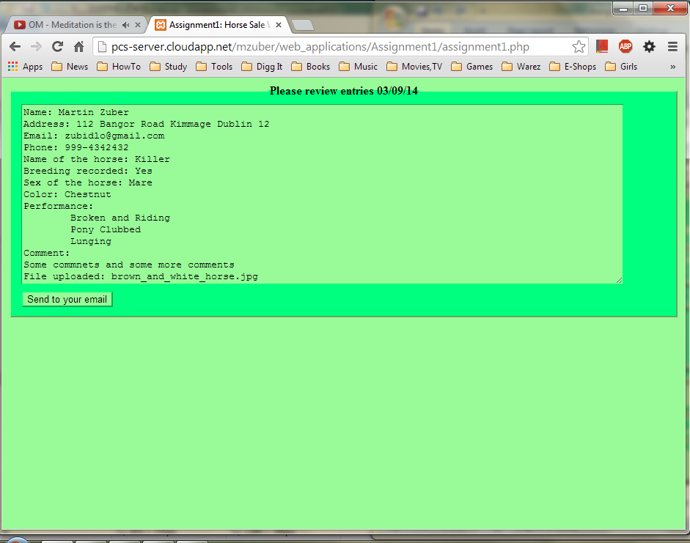

Figure 4